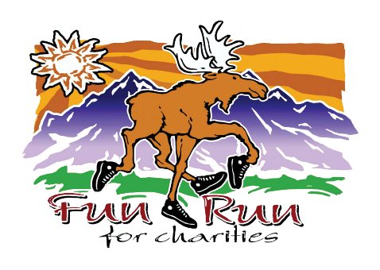

How To Attract Potential Supporters To Your Fun Run Booth
Your Fun Run booth presents an excellent opportunity to create awareness about your organization’s mission and connect with current and potential supporters. Just having a table with some info is not enough to lure in potential donors. You’ll need something to make you stand out from the crowd of other exhibitors. Here are a few tips to help you have a fun, appealing, and engaging booth that people want to visit! You can choose one or a combination of the suggestions below. As you read, keep in mind that the list below is meant to offer suggestions but isn’t a checklist or rulebook you must follow.
- Appeal to all 5 senses in your booth design
  - Sight: use bright colors, moving flags, wind socks, mobiles, banners, ribbons, table covers, or anything eye catching. If you have a 10x10 shade canopy, consider putting your table near the back of the booth and have a colorful rug in the front.
  - Sound: play an informational video about your organization on an electronic device with sound, background music that is loud enough to draw attention to your booth yet soft enough to still hold conversations; using things like bells, rattles, a soft wind chime, whistle, talking stuffed animal, squeaky toy, or kazoo, etc. can be fun so long as they still allow for conversation and don’t provide too much of a distraction
  - Touch: use fabrics, printed materials you encourage visitors to take, table top games, SWAG (Stuff We All Get)-branded with your logo if you can; FREE DRAWINGS are a huge hit even if for something simple or inexpensive such as an experience, a free membership to your organization, etc.
  - Taste Suggestions: have hard candy, chocolate, sanitary individually wrapped snacks, cookies, nuts in Dixie cups, or other goodies
  - Smell suggestions: a mild scented air freshener (sprayed under your booth so not too offensive, especially to those with allergies); a fresh bouquet of flowers or pine boughs; potpourri; fresh fragrant fruit, etc.
- Let your booth reflect your organization. If you are an arts organization, you could have a simple take-home art activity for kids. If you are an outdoor group, maybe share a top 10 list of favorite Red Lodge outdoor trails and activities. Get creative!
- Make eye and voice contact to lure a passerby into conversation and into your booth. Make light conversation or simply say, "Hello; thanks for coming to the Fun Run." Ask them if they are familiar with your organization; offer them a free (pen, notepad, chocolate kiss...).
- Have a brief description of your organization's mission, fundraising objective, contact information, board members, membership information, and more. Keep It Simple.
- Let visitors know that donations are still accepted the week following the Fun Run, and encourage them to support your charity.

Other Tips:
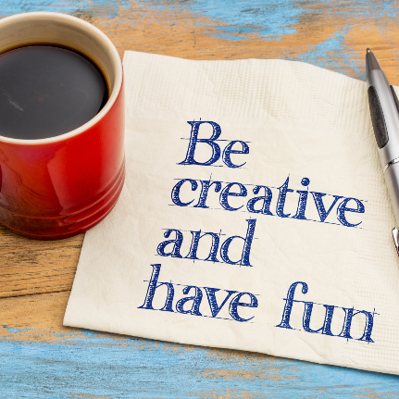
- Please remember that no donations can be accepted at the Fun Run booths on event day.
- No power is available to booths at Lion's Park. Please make an alternate plan.
- Red Lodge is notorious for rain, cool or hot temperatures or wind on Fun Run day. Please bring tent canopy weights, layers, tie downs and paper weights to make your - and your supporter's - experience a pleasant one.
- Need motivation? A prize will be awarded to the Best Fun Run Charity Booth winner each year.

