This donation form can be included in your printed newsletters and mailings. It is a convenient way for your supporters to make a donation to your charity via the Fun Run.

This form also streamlines donation processing at RLACF and helps ensure the donation is credited to the proper charity.

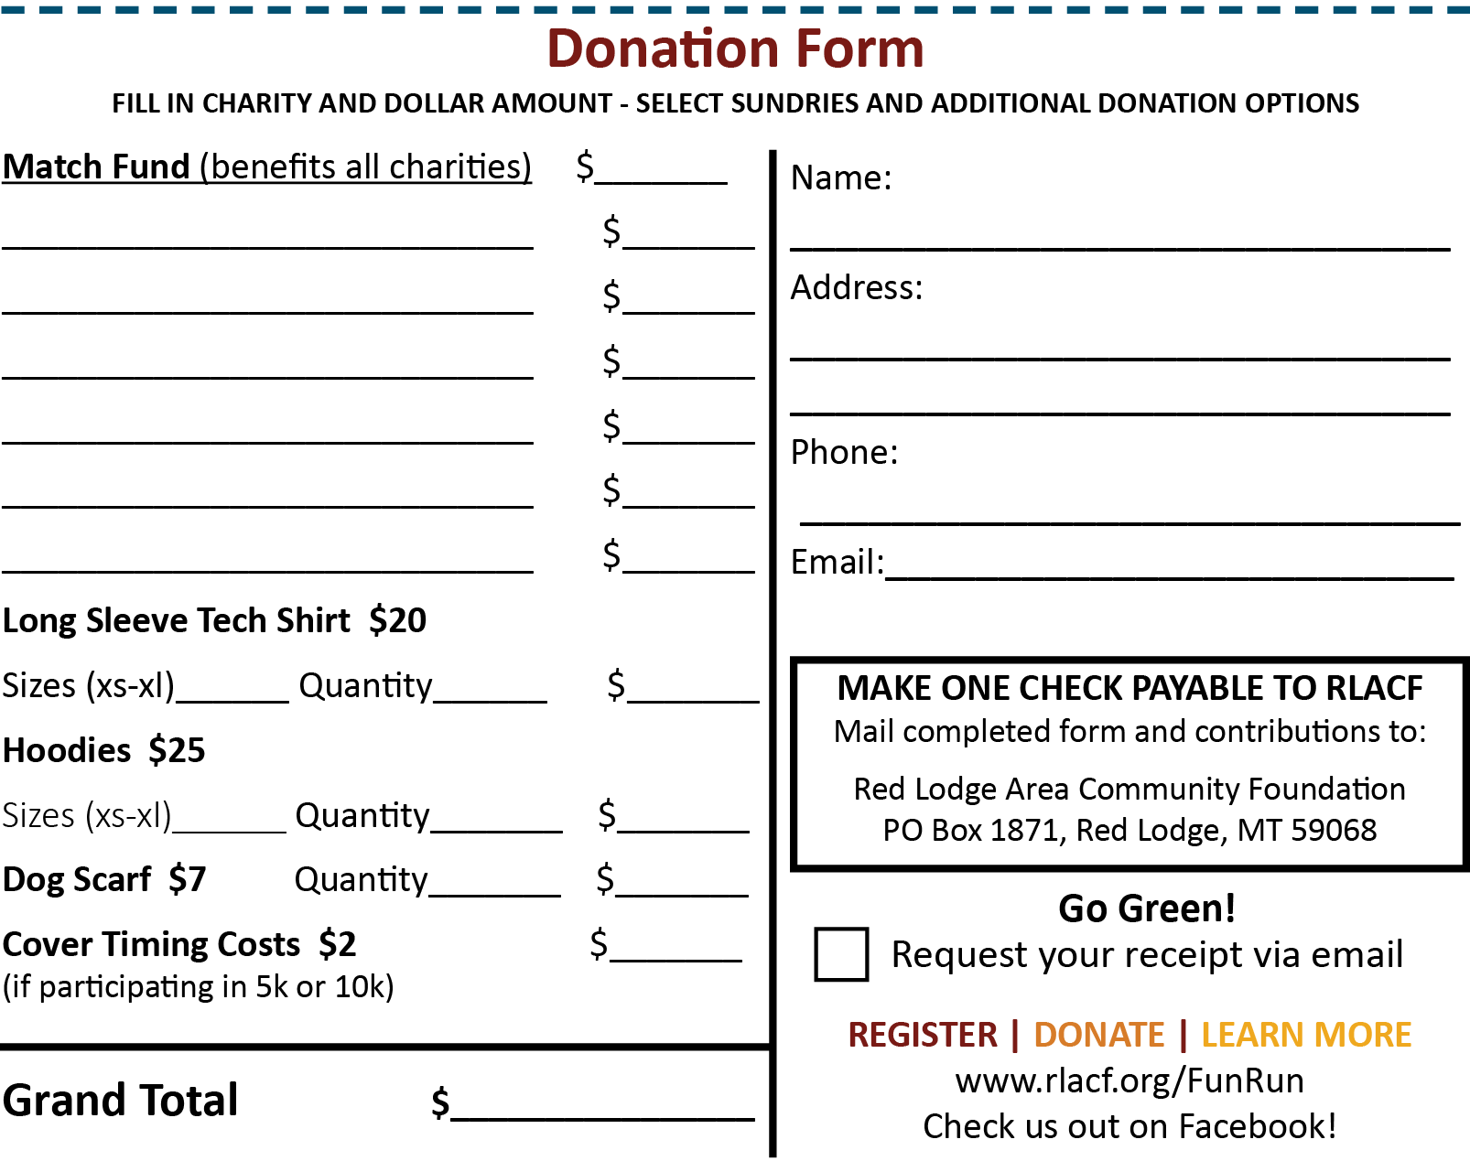
You can customize this top portion with your organization’s name and logo.

