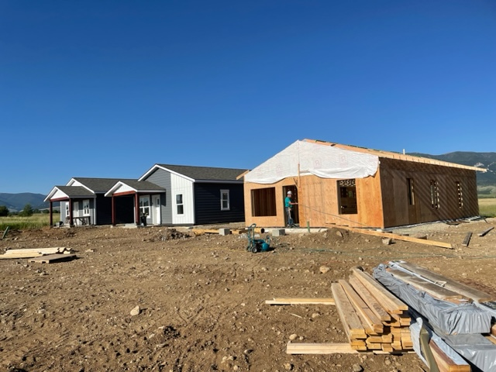
Owner-Built Housing Program
AT A GLANCE
The Red Lodge Area Community Foundation’s Workforce Housing Steering Committee has partnered with Helena Area Habitat for Humanity, Trust Montana, and USDA Rural Development to build modest and efficient single-family homes for qualified households in Carbon County. Six homes have already been completed in the Spires subdivision on the west bench, off Hwy 78.
Under the guidance of Helena Area Habitat for Humanity staff, qualified applicants are building their own homes, and the homes of their neighbors, with assistance from relatives, friends, and their community. This Owner-Built Workforce Housing program is for anyone that has stable income, positive credit, and minimal debt.
If you’re interested in building your own home and the homes of your neighbors, then this program may be for you.
Income Qualifications
Household Size | Maximum Income
1 | $71,700
2 | $71,700
3 | $71,700
4 | $71,700
5 | $94,650
6 | $94,650
7 | $94,650
8 | $94,650
OWNER-BUILT WORKFORCE HOUSING BENEFITS
- Earn equity in your home through your own labor.
- Low interest rates that may be modified by payment assistance.
- Up to 33-year payback period, with a 38-year payback period for some applicants based on income.
- No down payment required in most cases.
- Develop lasting relationships with neighbors building your homes together.
GUIDELINES
Skills: No construction skills necessary. You’ll be taught all you need to know.
Income: Income Qualifications are set per HUD 2023 Area Median Incomes for Carbon County (see above Table). Applicants must exhibit steady and verifiable income and live and/or work in Carbon County.
Credit History: Credit is reviewed and evaluated on a case-by-case basis. Free financial counseling sessions are available to support families and individuals with their credit and homeownership preparation.
Time Commitment: “Sweat equity” is the time commitment that all households contribute to building their homes and the homes of their neighbors. Contributing labor lowers costs and allows people to earn instant equity in their home. Commitment to 10 hours per week per applicant is required, with 1 weekday evening and 1 full-day Saturday every week for at least 1 years’ time or until all homes are move-in ready. Schedule may be flexible on a case-by-case basis if there are work-related conflicts.

HOW TO APPLY…
The first step is to fill out and submit a pre-qualification form. This is a short, pre-screening questionnaire that can be completed in a matter of minutes. From there, the form is reviewed, and you’ll hear back to set up a meeting.
Here’s how you can start your path towards homeownership:
- Fill out the pre-qualification form online: rlacf.org/housing/
- You can also pick up a hard copy from RLACF, or download and print from: rlacf.org/housing/
- If you fill out a hard copy of the form, please return it to Angela Getchell at RLACF by:
  - Mail: P.O. Box 1871, Red Lodge, MT, 59068
  - Email: angela@rlacf.org
  - In Person: Drop off at the RLACF office: 122 Hauser Ave S, Red Lodge, MT 59068

- Questions? Contact Angela Getchell (Workforce Housing Manager): angela@rlacf.org / 406-426-1983

